Project partners:
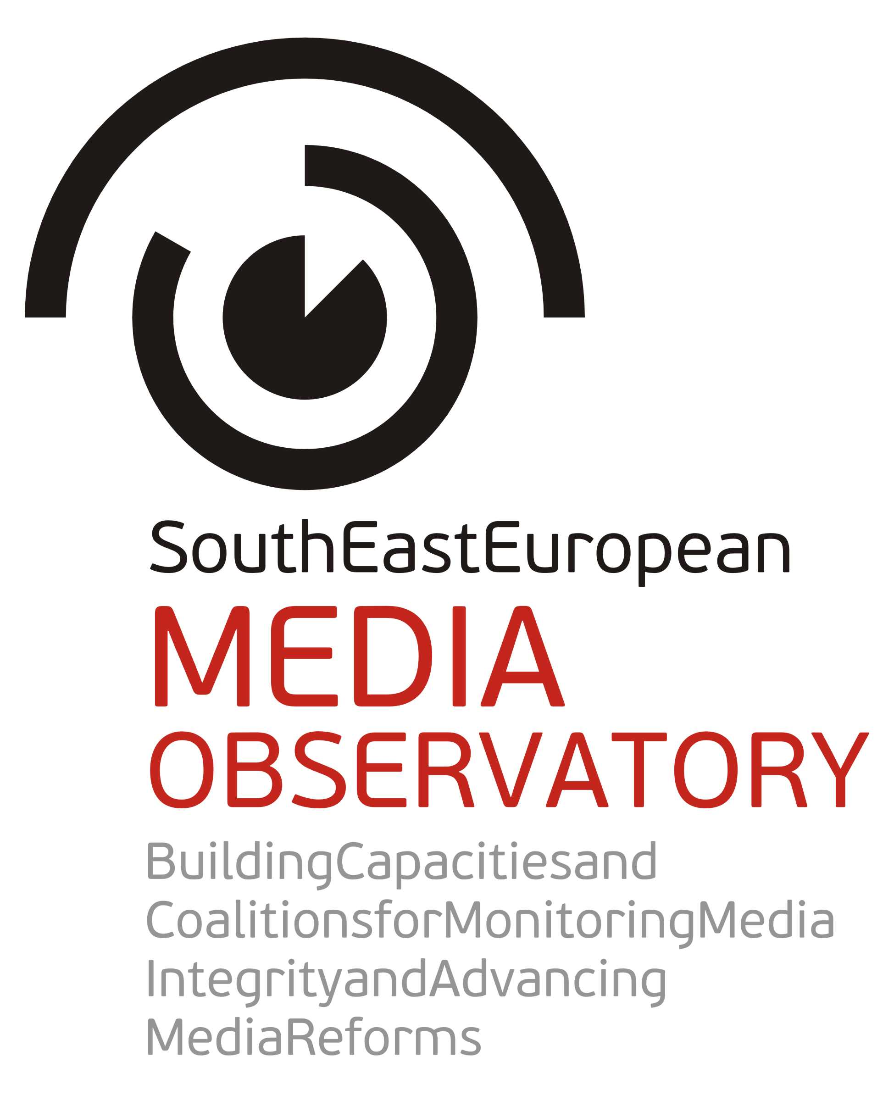 |  | 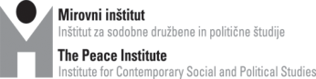
 |  | 
 |  | 
 |  | 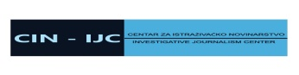
 |  | 
 |  | 
 |  | 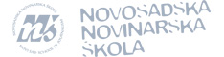

Central regional conference of the SEE Media Observatory:
“Media and journalism in South East Europe –
Captured by particular interests or turning to serve the public?”

12-13 June 2014
Tirana (Tirana International Hotel), Albania
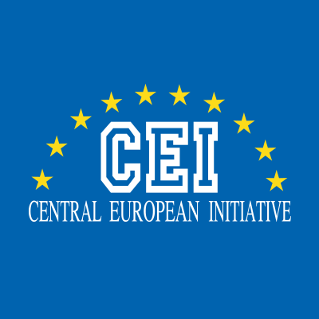 | With the support of Central European Initiative (CEI)  and Technical Assistance for Civil Society Organisations (TACSO) | 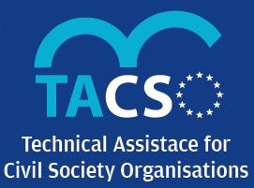

Aims: Central regional conference of the South East European Media Observatory aims at presentation and discussion on the findings of the media integrity research and investigative journalism projects in Albania, Bosnia and Herzegovina, Croatia, Macedonia and Serbia. The research employed a concept of media integrity to analyse and understand why the media (systems) in the region of SEE are as they are, and what influence their ability to serve public interest and democratic processes. The research applied a holistic approach, exploring media policy development and implementation, media ownership, media finances and public service broadcasting as well as situation of journalists and journalism. In the research methodology, 64 risks for media integrity have been identified to guide the researchers in their analyses.
The research was conducted between July 2013 and February 2014. In addition to the research, SEE Media Observatory supported 6 investigative journalism teams to conduct own research on corrupt practices in the media sector. More than 100 relevant actors have been consulted on media integrity issues through interviews and focus groups discussions. The research findings have been published in the book which will be distributed at the central regional conference, while partners will also publish the research findings in own language, and discuss them on national level.
The central regional conference in Tirana comes 10 years after the Bled conference, organized on 11-12 June 2004 at the end of the previous regional research of the network SEENPM “Media ownership and its impact on media independence and pluralism”. This time distance allows good opportunity for comparison.

Agenda
Thursday, 12 June 2014

9.00-9.30 Opening session

Chairperson: Remzi Lani, Director, Albanian Media Institute, Albania

Opening statements: Gentian Elezi, Deputy Minister of European Integration, Republic of Albania Clive Rumbold, Acting Head, Delegation of the European Union to Albania
Speaker: Brankica Petković, Peace Institute, Ljubljana, Coordinator of the SEE Media Observatory
“SEE Media Observatory: Why to research, protect and promote media integrity?”

9.30-11.00 Session 1

Media policy development and implementation: who rules and why legislation doesn’t work?

Chairperson/discussant: János Horvát, journalist, President of the Board of the Center for Independent Journalism, Hungary

Keynote speakers: Helena Popović, Professor, Faculty of Political Sciences, Zagreb, Croatia Snežana Trpevska, Professor, School of Journalism and PR, Skopje, Macedonia (both authors of the media integrity research reports)
Panelists:
Milan Živković, Head of the Media Department, Ministry of Culture, Croatia
Helena Mandić, Director of Broadcasting, Communication Regulatory Agency, Bosnia and Herzegovina
Milaim Fetai, Vice President, Agency for Audio and Audiovisual Media Services, Macedonia
Gent Ibrahimi, Director, Institute for Policy and Legal Studies, Albania

Open discussion

11.00-11.30 Break

11.30-13.00 Session 2

Media ownership – main patterns and risks for media integrity

Chairperson/discussant: Sandra B. Hrvatin, Professor, Faculty of Humanities, Koper, Slovenia SEE Media Observatory Advisory Board member

Keynote speaker: Sanela Hodžić, Research Coordinator, Media Center Sarajevo, BiH, author of the media integrity research report for Bosnia and Herzegovina

Panelists:
Nataša Tešanović, Director, ATV, Banja Luka, BiH
Željko Ivanović, Managing Editor, co-owner, Vijesti, Montenegro
Meri Jordanovska, investigative journalist, Macedonia, sub-grantee of SEE Media Observatory
Vaclav Štetka, Senior Research Fellow, Faculty of Social Sciences, Charles University, Czech Republic
Andrew Finkel, journalist, Funding Vice President, P24 – Platform for Independent Journalism, Turkey

Open discussion

13.00-14.30 Lunch

13.45-14.30 Side event (in the conference room):
Presentation of (a) the UNESCO World Trends in Freedom of Expression and Media Development, and (b) the UNESCO comprehensive study of Internet-related issues

14.30-16.00 Session 3

Media finances – is there a media market at all? To blame the industry or the state?

Chairperson/discussant: Saša Leković, journalist, Director, Investigative Journalism Center, Zagreb
Keynote speaker: Ilda Londo, Research Coordinator, Albanian Media Institute, Tirana, author of the media integrity research report for Albania

Panelists:
Senad Zaimović, President, Joint Industry Committee, Fabrika Agency, BiH
Besar Likmeta, investigative journalist, BIRN, Albania, sub-grantee of SEE Media Observatory
Agron Bajrami, Editor, Koha Ditore daily, Kosovo
Mladen Čadikovski, Director, Fokus weekly, Macedonia
Milan Živković, Head of the Media Department, Ministry of Culture, Croatia
Goran Klemenčič, former President of the Anti-corruption Commission, Slovenia

Open discussion

16.00-16.15 Break

16.15-17.45 Session 4

Public service broadcasting: governing and financing patterns - way of control and way of solution?

Chairperson/discussant: Marko Milosavljević, Professor, Faculty of Social Sciences, Ljubljana, Slovenia
Keynote speaker: Dubravka Valić Nedeljković, President of the Board, Novi Sad School of Journalism, co-author of the media integrity research report for Serbia

Panelists:
Sanja Mikleušević Pavić, News Editor and Presenter, HRT, Croatia
Mehmed Agović, Adviser, Ministry of Transport and Communication, former DG of BHRT
Lutfi Dervishi, media expert, former News Program Editor at TVSH, Albania
Radka Betcheva, Senior Project Manager, EBU Partnership Programme

Open discussion

19.30 Dinner in the city

Friday, 13 June 2014

9.00-11.00 Session 5

Journalists - Victims or constituents of structures and relations which obstruct democratic role of the media?

Chairperson/discussant: Boro Kontić, Director, Media Center Sarajevo, BiH

Keynote speaker: Jovanka Matić, Researcher, Institute of Social Sciences, Belgrade, co-author of the media integrity research report for Serbia

Panelists:

Duška Jurišić, journalist and editor, FTV BiH
Tamara Chausidis, President, Union of Journalists, Macedonia
Ilva Tare, journalist, Ora News, Albania
Yavuz Baydar, Co-founder, P24 – Platform for Independent Journalism, Turkey
Marijana Camović, President, Union of Journalists, Montenegro
Balazs Weyer, President, Hungarian Editors Forum, Budapest

Open discussion

11.00-11.15 Break

11.15-12.45 Session 6

External view and context: are media integrity problems a regional or wider problem?

Chairperson: Ilona Moricz, Director, Center for Independent Journalism, Budapest, Hungary
Keynote speaker: Aidan White, Director, Ethical Journalism Network, SEE Media Observatory Advisory Board member

Panelists:
Guy Berger, Director, Division of Freedom of Expression and Media Development, UNESCO
Karl Giacinti, Program Manager, European Commission, DG Enlargement
Leon Willems, Chairman, Global Forum for Media Development
Ross Biggam, Director General, Association of Commercial Television in Europe
Ewen MacAskill, journalist, Washington DC bureau chief 2007-2013, The Guardian, UK

Open discussion

13.00-14.00 Closing session:

Prospects for media integrity in SEE: Positive cases and Recommendations

Chairperson/discussant: Gordana Janković, Head, Media Department, OSCE Mission to Serbia
Keynote speaker: Sandra B. Hrvatin, Professor, Faculty of Humanities, Koper, Slovenia SEE Media Observatory Advisory Board member

Panelists:
Gordana Igrić, Director, Balkan Investigative Reporting Network
Biljana Petkovska, Director, Macedonian Institute for Media
Remzi Lani, Director, Albanian Media Institute
Brankica Petković, Peace Institute, Ljubljana, SEE Media Observatory Coordinator

Open discussion

14.00 Lunch

End of conference.

In 2013 and 2014, the SEE Media Observatory activities have been supported by the Open Society Foundations Program on Independent Journalism, Konrad Adenauer Stiftung Media Program for South East Europe, Open Society Foundation Serbia, Office for Cooperation with NGOs within the Government of the Republic of Croatia, Government of the Autonomous Province of Vojvodina, Department for International Development Cooperation Policies of the Ministry of Foreign Affairs in Slovenia, and the Guardian Foundation.

