Project partners:
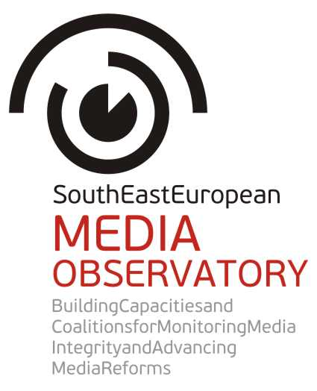 |  | 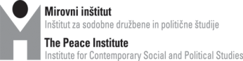
 |  | 
 |  | 
 |  | 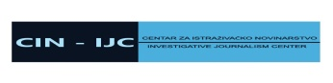
 |  | 
 |  | 
 |  | 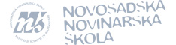

APPLICATION
FORM

FOR GRANTS TO IMPLEMENT
PUBLIC AWARENESS AND ADVOCACY CAMPAIGNS
ON MEDIA INTEGRITY IN SOUTH EAST EUROPE

Application deadline: February 28, 2014

Applicant data:
Name of the applicant organization:
English name of the organization:
Legal form of the organization (foundation, association, non-profit/social company)
Address of the organization:
Website of the organization
Tax number of the organization
Place and date of registration
Legal representative of the organization
Responsible for the grant (if the person is different than the legal representative)
Mailing address (if the registration address is different than the address where the organization is based):
Responsible person for the project (please only name one person)
E-mail address of the contacting person:
Phone number:
Planned starting date:
Planned completion date (end of project period):

Project description
1. Title of the project:
2. Please describe the core problem your proposal wants to address (max. 100 words)

a. What are the goals and objectives? (What specific change do you want to achieve by the end of the grant period and how will it contribute to the solution of the large problem? - max. 100 words)

b. What are the main target groups? (Who will participate in the actions, including cooperating partners, stakeholders and what social/professional groups will benefit from them? - max 100 words)

c. What activities do you plan to achieve the goals? (Please specify each of the actions and explain the methods why you want to use them, how they will lead to results - max. 500 words)

d/ What will be the results of these activities? (Please use indicators for each planned activity and describe how you will measure them? - max. 100 words)

e. What tools will you use to inform the public about the activities and results during and after the project period? (web-based communication, publications, media output, etc. - max. 100 words)

g. Timeline of the action (Please demonstrate the expected dates of the process of the project implementation (use a separate line for each activity) and the expected completion date.)
Activities | Month 1 | Month 2 | Month 3 | Month 4 | Month 5 | Month 6
Activity 1
Activity 2
Activity 3
Activity 4
Activity 5

h. Experience and capacity references
Please describe your organization's mission, scope of main activities, organizational structure. (max. 200 words)

i. Please describe max. 3 similar projects implemented by your organization. You can use links to show results, publications, tc.

Experience 1
Title and goal of the project
Results of the project (max 50 words)
Partnership (if relevant)
Total budget
Sponsor(s) of the project

Experience 3
Title and goal of the project
Results of the project (max 50 words)
Partnership (if relevant)
Total budget
Sponsor(s) of the project

Experience 3
Title and goal of the project
Results of the project (max 50 words)
Partnership (if relevant)
Total budget
Sponsor(s) of the project

Budget
Eligible costs are the expenses directly related to the proposed activities. All project expenses must be calculated in EUR. The budget narrative should describe the justification of the costs presented in the budget.

Eligible direct costs can be:
- costs of staff assigned to the project (salaries);
- travel/accommodation costs related to events,
- rental costs for equipment and supplies for the project activities
- costs of services - organization of events, costs of communication, printing, publication, translation, rent of event venues, meetings, and other services directly related to the proposed actions
- visibility and distribution items related to the activities (DVD, print paper, pens, etc.)

The purchase of any equipment is a non-eligible cost.
Justifiable indirect costs are also eligible (for example office rent, utilities, banking, book-keeping, etc.), but the ratio of such administrative costs should not exceed 7 percent of the total direct costs. Although these indirect costs do not have to be itemized, they will have to be accounted in the books of the organization according to the general rules of bookkeeping.
The budget should not exceed the maximum amount EUR 5000.
Please use the budget template in Excel format (a separate document of this Call for Proposals) where you can insert additional lines, if necessary.
3) Supporting documents

To assess eligibility of your organization, please enclose the following documents to the application form:
- copies of the founding document (deed of foundation or statutes) and the registration of the organization;
- copy of the latest annual report with the financial statement;
- statement by the legal representative on the financial and legal situation of the applicant organization.
These copies should be signed by the legal representative of the organization.
Application deadline
Applications should be submitted in English via e-mail to the Center for Independent Journalism at: seeapplications@cij.hu till 24:00 Friday, 28 February 2014. Do not mail paper-based applications.

South East European Media Observatory is a regional partnership of civil society organisations aimed at enhancing media freedom and pluralism, and influencing media reforms in the countries of South East Europe. It addresses obstacles to democratic development of media systems by providing a regional instrument for media research and monitoring, support to investigative journalism and civil society engagement. It also offers a regional framework for debates, consultations and coalitions among key stakeholders. SEE Media Observatory particularly addresses the problems with integrity of media and journalism in the region, focusing on harmful patterns of media ownership and media finances. In 2013 and 2014 the regional observatory concentrates on media integrity in Albania, Bosnia and Herzegovina, Croatia, Macedonia and Serbia. The partnership includes civil society organizations from two EU member neighbouring countries – Slovenia and Hungary, both with experience of media transition and ability to contribute to media reforms in the region by presenting lessons learned from successes and failures in democratic transition of media sector.
SEE Media Observatory is envisaged as a long term, continuous activity of the network of CSOs – South East European Network for Professionalization of the Media (SEENPM).

Coordinator of the Call for proposals for investigative reports on media in SEE Europe:
Center for Independent Journalism, Budapest, e-mail: seeapplications@cij.hu.

