Project partners:
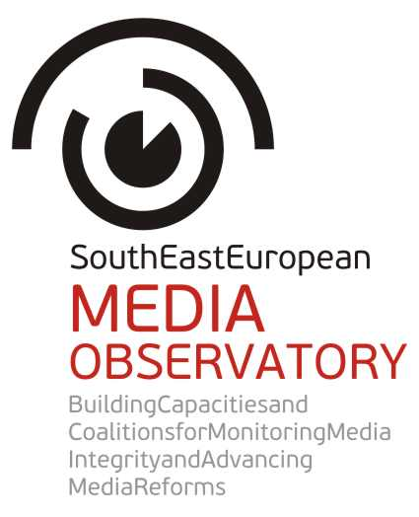 |  | 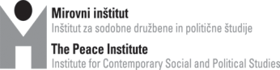
 |  | 
 |  | 
 |  | 
 |  | 
 |  | 
 |  | 



APPLICATION
FORM

GRANTS
FOR JOURNALISTS TO PRODUCE
INVESTIGATIVE STORIES
ON MEDIA
IN SOUTH EAST EUROPE

Application deadline: May 31, 2015

Please provide the following data:
Applicant data:
1. Name of the applicant:
2. E-mail address of the applicant:
3. Phone number of the applicant:
4. Status of the applicant (please choose the relevant answer below)
a/ Individual applicant as a natural person: yes
b/ Private entrepreneur: yes
c/ Investigative journalism center/company/non-profit organization: yes
d/ Team of journalists formed for this project: yes
5. If the applicant is an organization/institution/company, please provide the representative's name, title, phone number and e-mail address:
6. Please list the names of the team members who will be involved in the project:
7. Please attach a brief professional CV, resume or biography of the team leader and the team members showing their experience in investigative reporting/data-journalism/research/multimedia skills.

Project description (max. 1000 words)
1. Title of the project (story idea)?
2. Please describe the problem/corruption case you want to investigate.
3. How do you envisage to conduct the research? What methodology will you use?
4. How will you illustrate the collected data (graphic, video, audio, etc.)?

Budget
The budget sample below is to help journalists to plan their expected expenses. Please briefly explain what types of costs are necessary for the production of your proposed story.
Eligible costs:
- Direct expenses related to the production of the story, for example writer/videographer salaries or honoraria, public information data requests, travel costs, translation of researched data or documents to produce the story.
- Indirect costs (administrative costs) – for example office space rental, utilities, telecommunication, regular transportation costs which are not related to the story. The amount of such expenses should be maximum 7 % of the eligible project costs.
Please note that VAT might not be an eligible cost. VAT cost is eligible only if (i) the VAT is not recoverable by any means (ii); it is established that they are borne by the final beneficiary; and (iii) they are clearly identified in the project proposal. Budgets plan shall be reflected accordingly.
All project expenses must be calculated in EUR. The budget should not exceed the maximum amount EUR 5000.
You can use the budget sample below, but also change and insert additional lines, if necessary. The budget can also be submitted in another file format (for example Excel).
A budget sample:
 | Costs | Unit | # of units | Unit rate  (in EUR) | Costs  (in EUR)
1 | Production and honorary fees/salaries
2 | Travel/accommodation expenses
3 | Fee for research and access to data services
4 | Translation costs of the data requests and researched documents
5 | Printing/copying costs, tools of archiving, etc.)
6 | Other costs (please identify the special expenses the project may include)
 | Total direct costs:
7 | Administrative expenses max 7% of the total eligible costs
8 | Taxes , including VAT*  * VAT is eligible costs only if: (i) the VAT is not recoverable by any means (ii) it is established that they are borne by the final beneficiary; and (iii) they are clearly identified in the project proposal.
 | Total costs:
Timeline______________________________________________________________
Please describe the expected dates of the process of the project implementation (research, interviews, data visualization, publishing, etc.) and the expected date of the completion.
Type of activities | Month 1 | Month 2 | Month 3 | Month 4 | Month 5 | Month 6
1. preparations and research
2. ……………………………………….......
3. ……………………………………….......
4. ……………………………………….......
5. ……………………………………….......
6. ……………………………………….......
7. ……………………………………….......

Declaration of the applicant about guarantees of situation with no conflict of interest_____
Please read this declaration from below, and if you agree, print the full application form and submit the signed and scanned document as part with your application.

I, undersigned, declare that I am not in any personal, professional, political, economic, legal or any other conflict of interest with this proposal.

Place and date: .................................................................

Name (representative) of the applicant: ...................................................................

Signature of the applicant: ..................................................................
********
Checklist of Enclosures to this Application Form
1. References
Applicants must prove their professional capacities and therefore are required to submit three investigative articles (stories) published earlier on any subjects. They can attach scanned copies or provide existing links leading to these stories. Reference articles in local languages and/or English will be accepted.
2. Letter of intent
Please enclose a letter of intent from the publisher/editor-in-chief of the media organization interested in publishing the proposed story.

South East European Media Observatory is a regional partnership of civil society organisations aimed at enhancing media freedom and pluralism, and influencing media reforms in the countries of South East Europe.

It addresses obstacles to democratic development of media systems by providing a regional instrument for media research and monitoring, support to investigative journalism and civil society engagement. It also offers a regional framework for debates, consultations and coalitions among key stakeholders.

SEE Media Observatory stands for media integrity and journalism that serves public interest. These values are obstructed by corrupt relations and practices that integrated in the media systems. Corrupt media are deeply undemocratic institutions. Fight against corruption in the media, including the exposure of non-transparent ownership relations and funding methods and a critique of the fall of journalism as a practice of public control over the operation of governmental institutions, is simultaneously a fight for democracy.

Aiming to initiate and support public debate and policy actions in reclaiming public service values in media and journalism, SEE Media Observatory connects ten CSOs from Albania, Bosnia and Herzegovina, Croatia, Hungary, Kosovo, Macedonia, Montenegro, Serbia, Slovenia and Turkey. It is envisaged as a as a long term, continuous activity of the network of CSOs South East European Network for Professionalization of the Media (SEENPM).

In 2015 and 2016 its core activities are focused on media systems in the EU-enlargement countries.

Coordinator of the Call for proposals for investigative reports on media in SEE Europe:
Center for Independent Journalism, Budapest, e-mail: seeapplications@cij.hu.

